Software Design Description (SDD)

AI-Based ECG Image Digitization System

1. Introduction

1.1 Purpose
This Software Design Description (SDD) document presents the detailed design of the AI-Based ECG Image Digitization System. It translates the requirements defined in the approved Software Requirements Specification (SRS) into a clear architectural and component-level design. The document serves as a reference for system implementation and evaluation during the Final Year Project.

1.2 Scope
This SDD describes the internal design of the system, including:
- Overall system architecture
- Module-level design
- Data flow and processing pipeline
- AI model design
- User interface design
- Technology stack and deployment approach
The system converts scanned or photographed ECG paper-strip images into clean, digitized ECG signals using computer vision and deep learning techniques.

1.3 Definitions and Acronyms

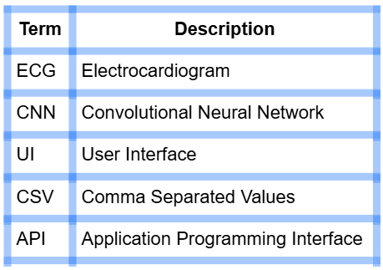

2. System Overview

2.1 System Description
The AI-Based ECG Image Digitization System is a web-based application that accepts ECG images as input, processes them through an AI-powered digitization pipeline, and produces a reconstructed digital ECG waveform in both numerical and visual formats. The system is designed to simplify ECG data digitization for medical, academic, and research use.

2.2 Design Goals
- Accurate extraction of ECG waveforms
- Minimal user interaction
- Modular and maintainable system design
- Acceptable processing time on standard hardware
- Support for future scalability and feature extension

3. System Architecture

3.1 High-Level Architecture
The system follows a layered architecture that separates user interaction, processing logic, AI-based analysis, and output generation. This design approach improves modularity, simplifies debugging, and allows individual components to be enhanced independently.
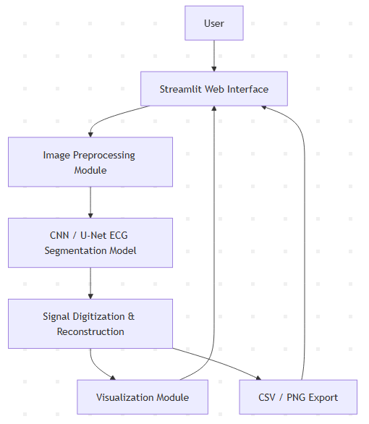
Figure 3.1: High-level system architecture of the AI-Based ECG Image Digitization System illustrating the interaction between the user interface, image preprocessing module, AI-based segmentation model, signal digitization and reconstruction, and output generation.

3.2 Architectural Components

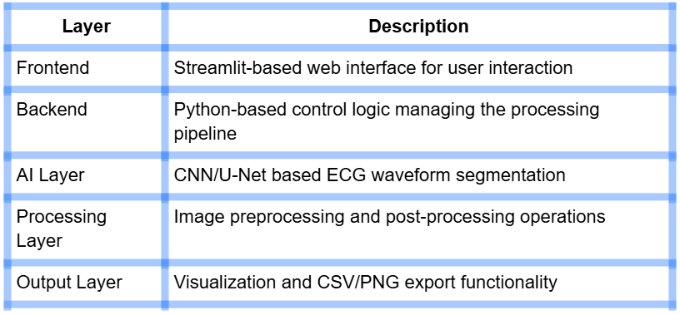

4. Module Design

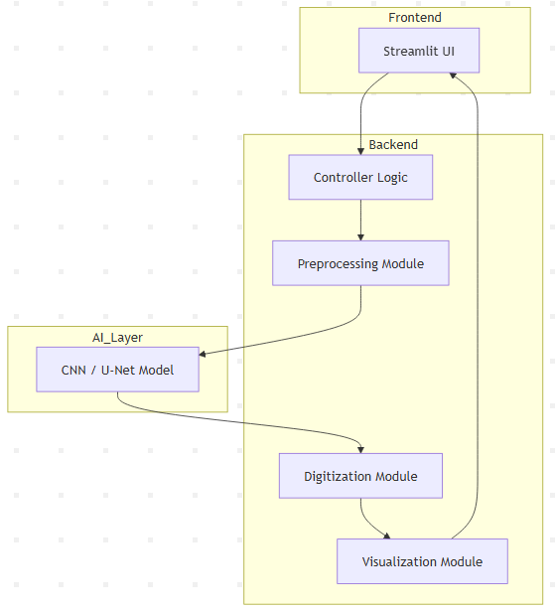

4.1 Module 1: User Interface Module
Responsibilities:
- Upload ECG images
- Display processing status
- Show original and digitized ECG outputs
- Provide download options for results
Technology Used:
- Streamlit
- Matplotlib

4.2 Module 2: Image Preprocessing Module
Responsibilities:
- Convert ECG image to grayscale
- Reduce background noise
- Remove gridlines and artifacts
- Enhance waveform contrast
Techniques Used:
- Gaussian blur
- Morphological operations
- Adaptive thresholding
Libraries:
- OpenCV
- NumPy

4.3 Module 3: ECG Waveform Detection Module
Responsibilities:
- Detect ECG trace pixels from the image
- Separate waveform from background
Model Architecture:
- CNN-based segmentation model
- U-Net architecture preferred for pixel-level accuracy
Input: Preprocessed ECG image
Output: Binary segmentation mask of ECG waveform
Framework:
- TensorFlow or PyTorch

4.4 Module 4: Signal Digitization and Reconstruction Module
Responsibilities:
- Convert waveform pixel coordinates into numerical ECG values
- Map image width to time axis
- Map image height to amplitude axis
- Smooth and normalize the reconstructed signal
Processing Steps:
- Extract waveform pixel coordinates
- Sort extracted points along the x-axis
- Interpolate missing signal values
- Normalize and smooth the signal
Output Format:
- CSV file containing time and amplitude values

4.5 Module 5: Visualization and Export Module
Responsibilities:
- Plot the reconstructed ECG signal
- Display extracted waveform overlay
- Enable CSV and image file downloads
Libraries Used:
- Matplotlib
- Pandas

5. Data Design
The system processes ECG images through a sequential data pipeline. Data flows from image acquisition to waveform extraction, signal reconstruction, and export, ensuring consistency throughout all processing stages.
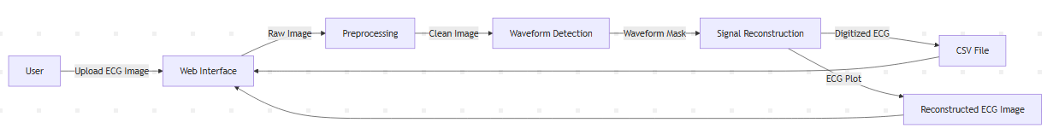

5.1 Input Data

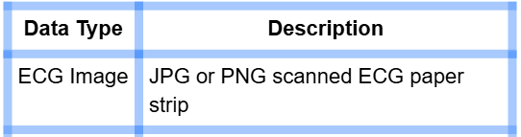

5.2 Intermediate Data

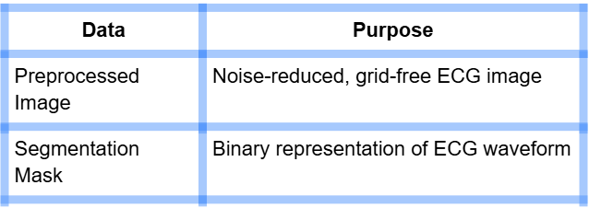

5.3 Output Data

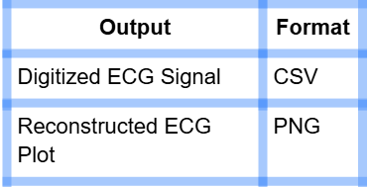

6. AI Model Design

6.1 Model Type
The ECG waveform detection component is implemented using a convolutional neural network-based segmentation approach. A U-Net architecture is preferred due to its ability to preserve fine waveform details while performing pixel-level classification.

6.2 Training Dataset
- Kaggle ECG Digitization Challenge Dataset
- Augmented ECG image samples

6.3 Loss Function
- Binary Cross Entropy
- Dice Loss (optional, for improved segmentation accuracy)

6.4 Evaluation Metrics
- Pixel accuracy
- Intersection over Union (IoU)
- Visual quality of reconstructed ECG waveform

7. User Interface Design

7.1 UI Flow
- User uploads ECG image
- User initiates digitization process
- System displays results
- User downloads digitized ECG
7.2 UI Components

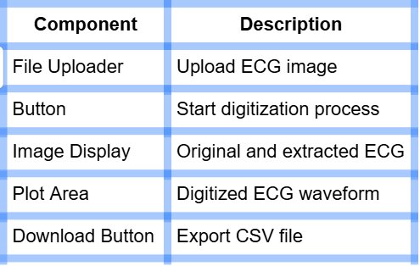

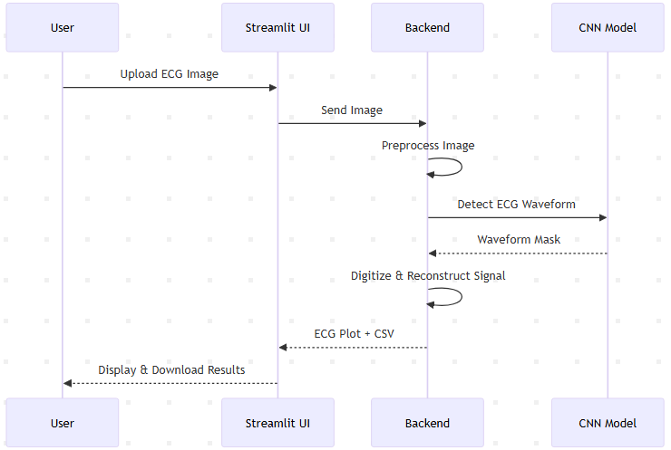

8. Security and Privacy Design
The system processes uploaded ECG images in temporary memory without permanent storage. No personal or patient-identifiable data is collected or retained, ensuring basic privacy and security compliance.

9. Deployment Design

9.1 Development Environment
- Python 3.8 or higher
- Local machine or Google Colab

9.2 Deployment Options
- Local Streamlit application
- Optional cloud-based deployment for scalability
The system design supports efficient execution on both CPU and GPU environments.

10. Future Scalability Design
- Batch ECG image processing
- Multi-lead ECG digitization
- REST API integration
- Automated ECG abnormality detection after digitization

11. Conclusion
This Software Design Description presents a complete and well-structured design for the AI-Based ECG Image Digitization System. The design aligns with the approved SRS and provides a solid foundation for implementation, testing, and future enhancement as my Final Year Project.

